2200031128 CH BHAVANA
WEEK 8 TASK 3
Objectives
- Explain branching and merging
- Explain about creating a branch request in GitLab
- Explain about creating a merge request in GitLab
In this hands-on lab, you will learn how to:
- Construct a branch, do some changes in the branch, and merge it with master (or trunk)
Prerequisites
The following are the pre-requisites to complete this hands-on lab:
- Setting up Git environment with P4Merge tool for Windows
Notes*:
Please follow the below steps for creating a free account in GitHub.
Do not use cognizant credentials to login to GitHub.

Estimated time to complete this lab: 30 minutes.
Please follow the instruction to complete the hands-on. Each instruction expects a command for the Git .

Branching:
- Create a new branch “GitNewBranch”.
- List all the local and remote branches available in the current trunk. Observe the “*” mark which denote the current pointing branch.
- Switch to the newly created branch. Add some files to it with some contents.
- Commit the changes to the branch.
- Check the status with “git status” command.

Merging:
- Switch to the master
- List out all the differences between trunk and branch. These provide the differences in command line interface.
- List out all the visual differences between master and branch using P4Merge tool.
- Merge the source branch to the trunk.
- Observe the logging after merging using “git log –oneline –graph –decorate”
- Delete the branch after merging with the trunk and observe the git status.

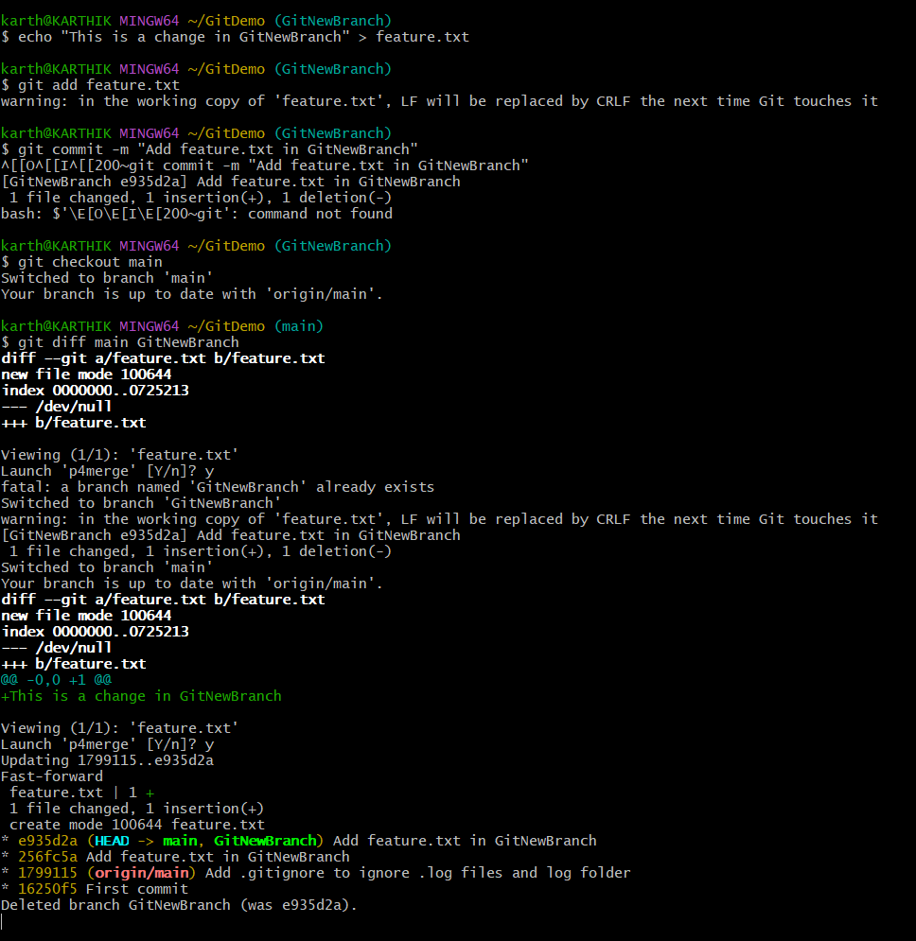
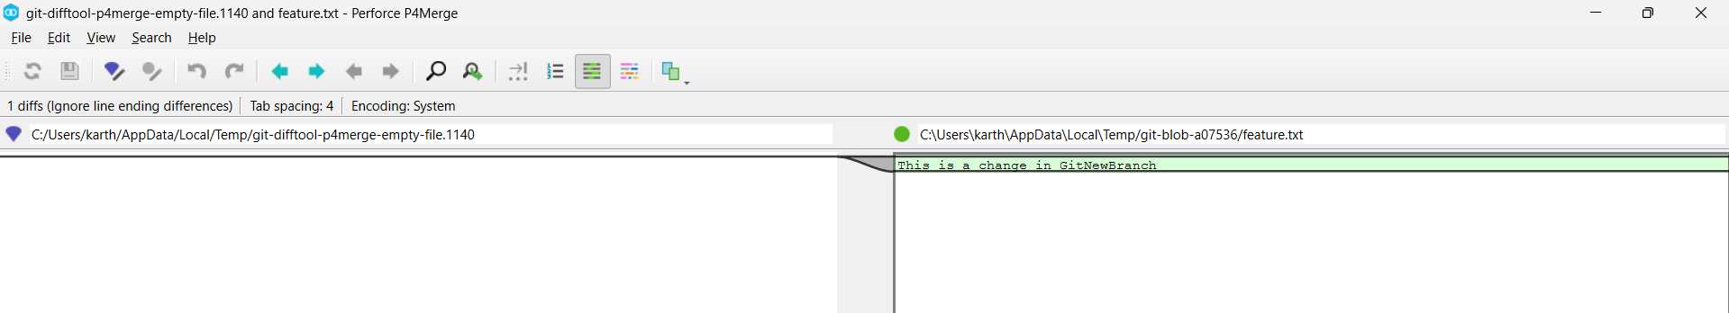
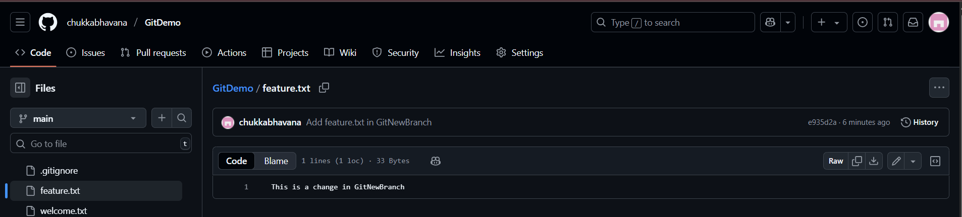

Theory: Branching and Merging in Git
1. What is a branch?
- A branch is simply a pointer to a specific commit in Git history.
- The default branch is usually main (or master).
- Branches allow isolated development — changes on one branch don’t affect others until merged.
2. Creating a new branch
- Command: git branch GitNewBranch
- This makes a new pointer to the same commit as the current branch, but you are still on the old branch until you switch.
- Viewing branches (git branch) shows a * next to the current branch.
3. Switching to the branch
- Command: git checkout GitNewBranch or git switch GitNewBranch
- Now HEAD points to the new branch, and your working directory reflects its snapshot.
4. Making changes in the branch
- Any files added/modified/committed here belong only to this branch’s history.
- Example:
  - Create a new file feature.txt
  - Stage with git add feature.txt
  - Commit with git commit -m "Add feature.txt in GitNewBranch"
5. Switching back to main
- Command git checkout main
- This changes your working directory back to the snapshot of the main branch.
6. Comparing branches
- CLI difference: git diff main GitNewBranch Shows line-by-line differences between branches.
- Visual difference (P4Merge, Meld, etc.): git difftool main GitNewBranch Opens a GUI tool to view changes.
7. Merging
- Merging integrates changes from one branch into another.
- Command git merge GitNewBranch
- If the main branch has no new commits, the merge may be a fast-forward — just moves the branch pointer forward.
- If both have new commits, Git creates a merge commit and may require conflict resolution.

